Three Metaphors and a Paradox
Or how to prepare for an oral presentation

First metaphor – Tell us a story

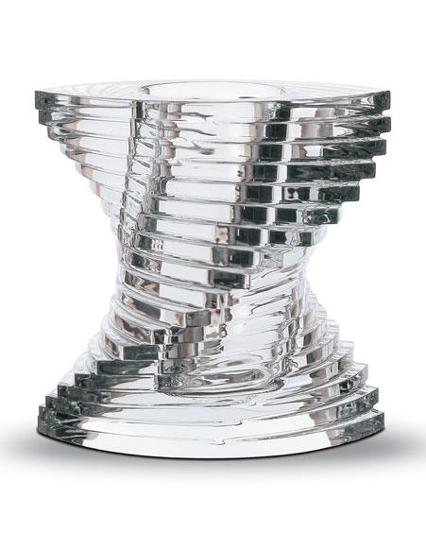 | A story is like a crystal -- transparent and multifaceted.  It focuses reality in a fascinating way that mesmerizes the eye, stirs the emotions and moves the mind.  Stories can make your presentations more memorable and more fun, and they can help advance audience toward knowledge.  Crystal by Baccarat

Now you have a story; you have gathered the documentation, you have become familiar with the vocabulary and the main concepts, and you are about to set to organising things.

Second metaphor – Tailor made for one show
Photograps Sources 1D-photo.com & Phileicanon
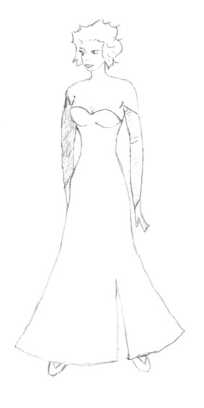 | Step 1: the Outline  Write a sketch to give your presentation a general line.  Typical questions to answer:  - Who's the audience? Friends, professionals, colleagues?  - What do I want to show, demonstrate or prove?  - What do they know about it?  - What's my initial question again?

Step 2: Preparing the different pieces of the puzzle  - First things first, start with your conclusion  - Then think of a sexy introduction  - How many parts do I need for the body of the talk? How many stops from A to Z? | 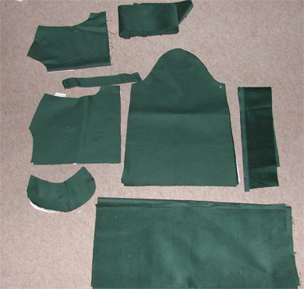

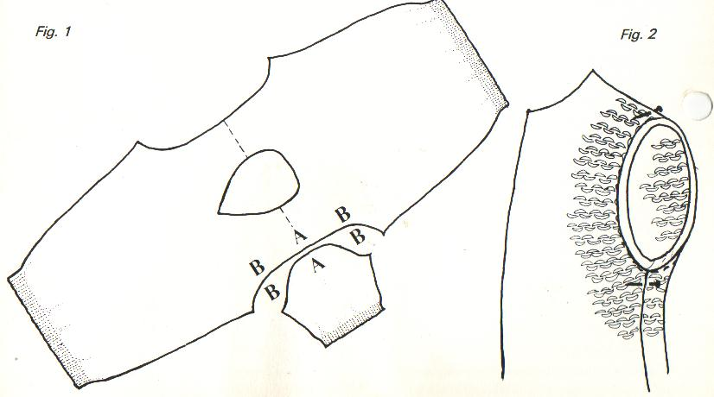 | Step 3: Getting a global picture  - How do I get to the conclusion?  - Does the whole thing make sense?  - Is it that part really in the right place?  - Will I feel comfortable with this?  - What if I did that instead?  - This part is useless, I'll dump it!

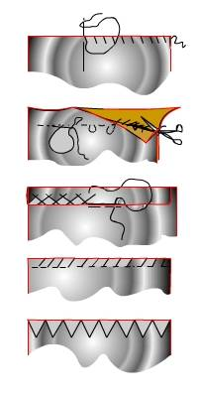 | Step 4; A stitch ins time saves nine  Time now to decide on the links you're going to use.  - Which link words? Which metaphors? Examples?  - Where to put rhetorical questions? How to keep them interested?  - How can I sum up the last part and announce the following one?  Haven't we forgotten to check on the pronunciation?

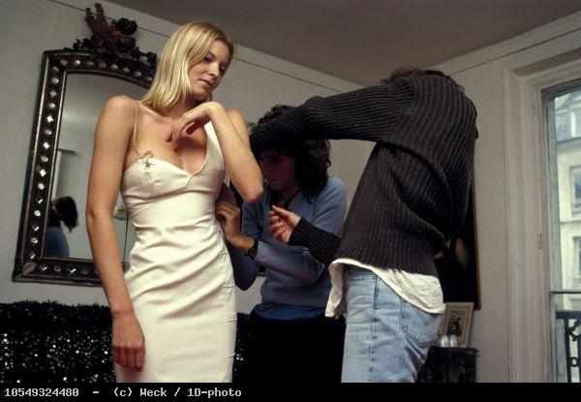 | Step 5: Adjustments  - Try your presentation on.  - Ask a friend to listen to you or use your camcorder or even a mirror  - Watch the timing  Adjust thanks to the feedback you get.

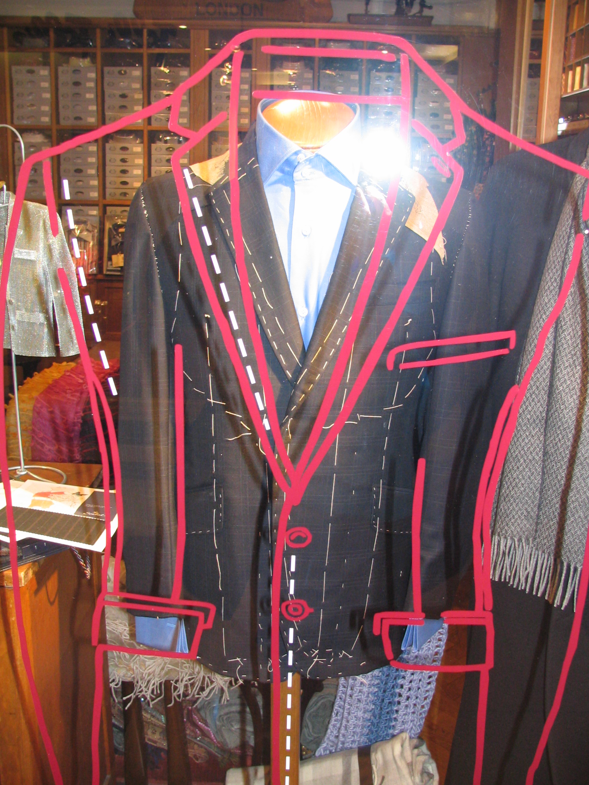 | Step 6: Final checks  Once you have performed the coarse / raw presentation, you'll have to:  - check you're meeting you objectives and keeping to the initial outline.  - watch that the seams don't show  - iron out the last problems with pronunciation  - learn your part and brush up frequently

Step 7: Conquer the world  After so much preparation, thinking and rehearsal, make the most of the time allotted to you.  - Breathe out!  - Smile!  - Move forward!  - Be "aware" of the audience.  - Adapt your strides to their pace.  - Look confident.  - Take their hand and tell them the most beautiful story they've ever heard.  Forget about the dull taxman sitting at the back of the room. | 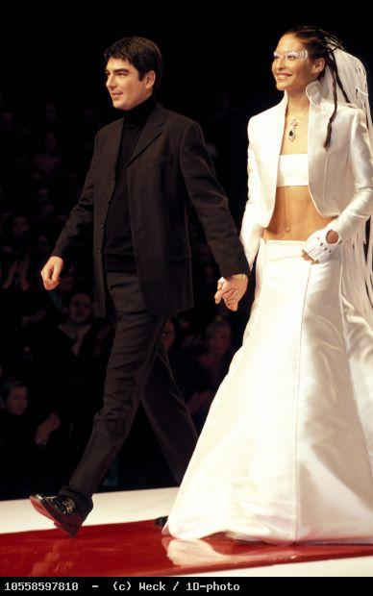

Third Metaphor: English is like a chandelier

I like the metaphor of crystal as, when you think of it, Baccarat, Murano or Swarovski all turn sand into diamonds. This requires knowledge, know-how and time. None is given but they may be acquired.
Once you have, you'll enjoy both the pleasure of a well done job and the satisfaction of audiences that DO listen to you.
So I'd like you to imagine that your English will be more like this piece of craftsmanship, when you have paid attention to the features illustrated below.

FIREWORKS ENGLISH

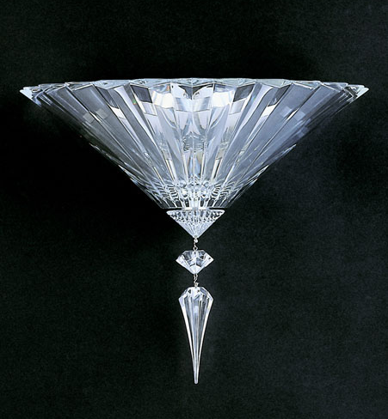
Purity vowels
Smoothness
voice quality
Sharpness consonants
Attention to detail vocabulary
Rhythm and intonation
Pauses / breath
Voice modulation
Fluency
speech delivery
Focus concentration
wit
Structure
In cauda venenum
grammar

Paradox: Wax Your Words
SOURCE : http://ecglink.com/library/ps/wax.html

On the one hand, wax was used by crooks to trick Romans into buying faulty statues; once the wax had melted, the cracks in the stone would show. This should not happen to you during a presentation.

On the other hand, students are regularly 'invited" to improve their language skills by using phrases that look and sound English (see below).

Well, paradoxically, these phrases may be considered as wax when communication is concerned. They hinder clear ideas from getting across straight to an audience.

Here is a series of examples taken from the web or from real life.
What do you think?

-----------------------------------------------------------------------------------------------------------------

Superlatives are wax.
- “This is essential!” “This is absolutely and positively essential!”
- “This is essential!” “This is true beyond any possible shadow of a doubt!”

If you wish to strengthen the simple assertion. “This is true!”, you can also do so by pouring concrete examples to support it.

Trite expressions are wax.

- “As you can see,”  - “if you will,"  - “in conclusion,”  - “it is indeed both an honour and a privilege,”  - “I would like to take a few minutes,”  - “Each and every one,”  - “throughout the length and breadth of the land,”  - "indeed, …" | - "So to say"  - "See what I mean!"  - "In a way"  - "To some extent"  - "…, you know, …"  - "some kind of", "sort of"  - "Mind you!"  - "Mark my words"
Groping expressions are wax.
- “What I'm trying to get at is ...,”
- “What I want to say is ...”

If you want to say something, say it! Why not try a concrete example instead.

Repetitious expressions are wax.
- “As I said before,”
- “and so I again repeat,”
- “let me reiterate here...”

If you wish to gain the emphasis which comes from restatement—as you do in the opening and close of a conference comment—go ahead and restate.

“And so forth” expressions are wax.
- “America has produced such inventors as Fulton, Edison, the Wright brothers—and so forth and so on.”
- “Our marketing recommendations are now based on research, data, statistical analysis, etc., etc."”
- See what I mean!

Weasel words are wax.
- “Of course, it's only my opinion, but ... .”
- “It seems to me ... .”.
- “More or less...
- to a greater or lesser degree...
- or something like that...”

Should I avoid word wax?

She who cleans her speech of waxy substance creates a lasting impression of intelligence, directness, and professionalism. Be sincere. Carve your communications without wax: you may rate a marble statue in the end.

(Biased on Public Speaking As Listeners Like It, by Richard C. Borden, Harper Collins, 10 East 53rd Street, NY, NY 10022.)

Miscellaneous
Rhetorical questions
- And what have we got here? Here, we've got a new ….
- What's a barrister? A barrister is …

- You may not all know where it took place. Well, it happened …

Aim at introducing new information while stressing on its importance. Help revive attention when audience is losing concentration.

Using auxiliaries to stress upon important pieces of information
- He killed her.  - Oh no, he didn't.  - Yes, yes. He DID kill her. | - I love you, I want to marry you.  - Come off it, will you. Leave me alone!  - But I DO love you!

Save your time, your energy and your words

It is not impossible for me to say I may say
It is difficult to buy a house for oneself Buying a home is easy.

